Nutrition Assessment (Elementary School Level)

Directions:
- Write down food log for Sunday, Monday, and Tuesday.
- Write foods in the Food column under which meal it is.
- Write amounts in the proper food group.
- Add columns down for the total of each group.
- Compare your totals to the amounts below.
- Food Group Goals:
  - Fruit- 1 ½ cups
  - Vegetables- 2 ½ cups
  - Grains- 6 oz. (1 oz= 1 slice of bread, 1 cup of cereal)
  - Meat/Bean- 5 oz. (1 oz= 1 egg)
  - Milk- 3 cups (1 cup= yogurt cup)

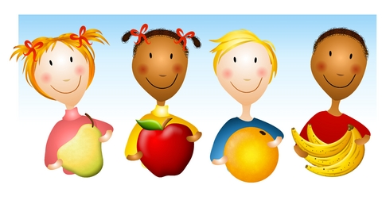
Day 1
Food | Fruit | Vegetables | Grains | Meat/Bean | Milk
Breakfast:
Lunch:
Dinner:
Snacks:
TOTAL

Did you meet the goals? Yes No

Day 2
 | Fruit | Vegetables | Grains | Meat/Bean | Milk
Breakfast:
Lunch:
Dinner:
Snacks:
TOTAL

Did you meet the goals? Yes No

Day 3
 | Fruit | Vegetables | Grains | Meat/Bean | Milk
Breakfast:
Lunch:
Dinner:
Snacks:
TOTAL

Did you meet the goals? Yes No

