Health Education Lesson Plan: Drugs and Medications
February 28, 2012

Descriptive Information

Skill Emphasis (NHES): Analyzing Influences

Grade Level: 9th Grade

Content Area of Health: ATOD

Content Descriptor & Sub-Descriptor(s):
1. Short-Term and Long-Term Benefits and Risks of Medicinal Drugs
1.1 Risk of dependence and addiction.
1.2 Physical, social, and emotional effects of AOD use.

Title of Lesson: Preventing Communicable Disease

PA Standard (Health & PE):
10.1.9.E. Analyze how personal choice, disease and genetics can impact health maintenances and disease prevention.
10.2.9.C. Analyze media health and safety messages and describe their impact on personal health and safety..

Adolescent Risk Behavior (if applicable): Drug Use

Behavioral Objective(s)
Cognitive: The student will demonstrate understanding of the day’s information by taking personal notes on the information.

Cognitive: The student will demonstrate comprehension of the difference between the terms medication and drug by responding to the essential question of the day.

Affective: The student will demonstrate cooperative team work skills by working with others during the media activity.

Skill Based: Analyzing Influences- The student will observe a video and discuss with a group the differences between different ads and how the medications are portrayed by the media.

Brief Outline of Today’s Lesson
- Introduction
- Bell Ringer
- Content
- In-Class Media Activity

Expanded Outline of Today’s Lesson

1.Introduction to the Lesson (Set Induction): “Today, we are going to discuss the difference between medications and drugs. Does anyone here take a drug daily or know a person who takes a drug daily? To start, we are going to do an activity called the “Anonymous Question Box”. Inside the box, there is a cup and colored paper clips. According to which one of these you fit into, place that color paper clip in the top slip of the cup. Like the name, it’s all anonymous.“

Colors were as followed:
- Red = I take a daily medication
- Green = My parent(s) take a daily medication
- Pink = A sibling takes a daily medication
- Yellow = A friend takes a daily medication
- Blue = No one I know takes a daily medication
- White = Pass

2.Bell Ringer (Instant Activity):
(Posted on Blackboard) The students will answer the question on the board in their notebooks to start their notes for the day. The Question for today will read as such:
“Who in your life uses medications daily?”

3.Content & Instructional Strategies:
- Classifications
  - Medicines – drugs that are used to treat or prevent disease or other conditions
  - Drugs – substances other than food that change the structure or function of the body or mind
- All medicines are drugs but not all drugs are medicines
  - Medicines can be sorted into 4 broad categories:
    - Disease Prevention
    - Fight Pathogens
    - Pain Relieve
    - Health Promotion
  - Disease Prevention
    - Vaccines
      - preparation introduced into the body to stimulate an immune response
      - contain weakened or dead pathogens that stimulate your body to produce specific antibodies against those pathogens
    - Antitoxins
      - extracts of blood fluids that contain antibodies and act more quickly than antibodies, produced by inoculating animals
  - Medicines that Fight Pathogens
    - Antibiotics
      - work either by killing harmful bacteria in the body or by preventing bacteria from reproducing.
    - Common Antibiotic
      - Penicillin
      - Typically end in the letters “IN”
    - Numerous “Generations” due to adaptations of the diseases
  - Pain Relievers
    - Most common are analgesics or pain relievers
      - Ex. Advil, Tylenol, Aleve, Motrin
    - Mild: Aspirin (Ex. Bayer)
      - Can be taken daily to prevent heart attack or stroke
    - Strong: Morphine and Codeine
      - Dr. prescribed regiments only
      - Used for extreme pain relieve
      - Addiction, Tolerance, Withdrawal
  - Health Promotion
    - allergy medicines
      - Benadryl, Zyrtec, Clariton, Sudafed
    - body-regulating medicines
      - Lipitor, Os-Cal , Ambien
    - antidepressant and antipsychotic medicines
      - Prozac, Xanex
    - cancer treatment medicines
- Media’s Take on Drugs
  - Youtube videos:
    - Livita- shows the list of side-effects named by drug companies.
    - Media Deception- explains how the drug companies create commercials and how the words and images are strategically placed together.
- In-Class Activity- Media’s Take
  - In groups, look at the ad given to you for a health promotion drug.
  - On a piece of paper, use the picture and your group members to answer the following questions:
    - What is this ad for?
    - What age group is this ad trying to appeal to? Why?
    - What “image” is this ad trying to portray?
    - If you did not know this ad was for a drug, what do you think the ad would be for?
- Out of class Assignment
  - Assign homework to write a reflection on the lesson taught today.

4. Final Thoughts/Conclusion to the Lesson

The students will answer the Essential Question posted on the board, which asks the student to reflect on the information taught during the lesson. The self-reflection will be handed in before exiting the classroom at the end of the period.
Essential Question: “What is the difference between drugs and medications?”

5. Classroom Management & Materials

- Classroom Materials
  - Handouts/Worksheets: Handouts will be used strictly for observation so that the students can see them. All students will use their own notebook paper for classroom activities.

  - Other Materials: PowerPoint will be used to relay the information. Students will be responsible to take their own notes.

    - Classroom Management
      - For In-Class Learning Activity: students will break into groups of 4 or 5 to discuss the ad image.

Content References
Mr. Mike Minarchick. PE and Health Instructor. Philipsburg-Osceola High School.

Time Magazine (16 May 2008). Deceptive Drug Ads. Retrieved from http://www.youtube.com/watch?v=C7FGtYVQMFc.

Activity Reference(s)
Beth Berger. PE and Health Instructor. The Pennsylvania State University. (717) 404-2967.

Appendix
- Ad Pictures for In-Class Activity (Small)

Teacher Reflection
Strengths:
- The lesson ran majority of the period today, which was good.
- I had good activities to end on and to change the lesson from just lecture.
Improvements:
- I need to get more feedback from some of my classes so that they are fully engaged during the lesson.
- I need to also change up my way of information delivery. Taking notes from a lecture is quite boring and the students do not like it.
Insights:
- I would like to get each child more personally involved during the next classes, so they each relate very well to the material.
LIPITOR LUNESTA CELEBREX
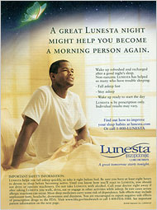

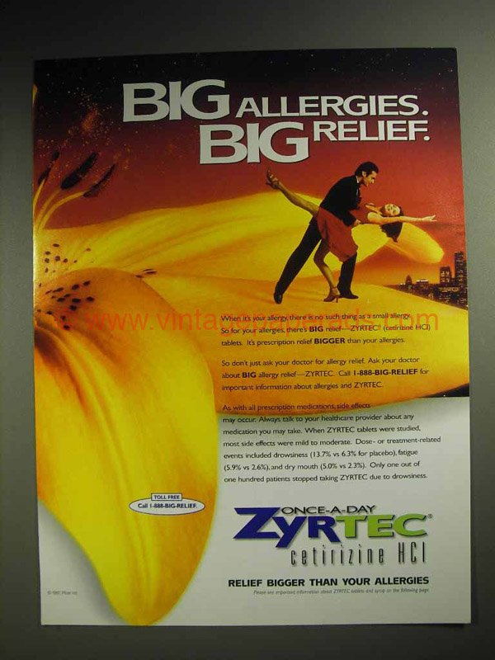
PROZAC ZYRTEC ZOLOF
